Liz Jeannet Acupuncture
White Crane Clinic NW1 8XE & Olney Treatment Rooms MK46 4LA www.lizjeannet.com liz@lizjeannet.com 07764 604998
Registration Form – Private & Confidential

Patient Details
Name | GP’s Name
Address | GP’s Address
Postcode | GP’s Phone No
Home Phone No | If we need to contact your doctor do you prefer this to be
Work Phone No | your GP or specialist – give details if not as above
Mobile Phone No
email
Date of birth:
Occupation: | Are you receiving any other therapies – give details
How did you hear about us?
Reason for your visit
1. Presenting Condition |  | Duration
2. Presenting Condition |  | Duration
3. Presenting Condition |  | Duration

Medical History
Date | (please include illness/surgery/accidents/hospital admissions/seizures/fainting/bleeding disorders)

Investigations in last 3 years
Blood tests | When and why did you last see your doctor
X-rays
Ultrasound
MRI
Other – give details

Family health history
Illness and age of onset

Mother

Mother’s parents
Father
Father’s parents
Siblings
Are there any disease traits (e.g. arthritis, cancer, heart disease, epilepsy, diabetes) in your family?

General
Weight | Alcohol
Height | Tobacco
Allergies | Recreational drugs
For women, date of last menstrual period | Do you have a pacemaker or other electrical implant

Pain and Symptom Map
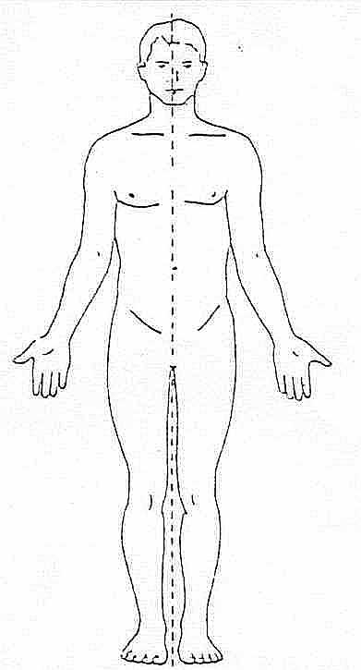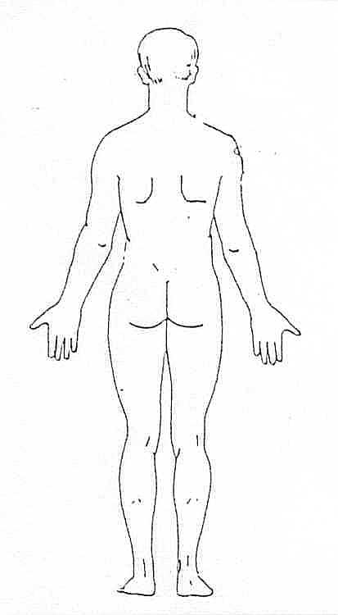 | Please mark areas of  - Pain  - Numbness  - Tingling  - Pins and needles  - Other symptoms – give details

Symptom checklist – please tick if you’ve had in last 3 months
Pain | Headaches
Fatigue | Shortness of breath
Weight loss/gain | Palpitations
Anxiety/depression | Cough
Sleep difficulties | Digestive problems
Fevers/night sweats | Nausea or vomiting
Swollen glands | Diarrhoea or constipation
Visual problems | Urinary tract symptoms
Hearing difficulties | Skin rashes
Bleeding gums, Mouth ulcers | Lumps or unexplained bleeding

Medication - please give name and dosage
Prescription medication | Over-the-counter medication & supplements

What is your priority in terms of treatment today?

